**CS-322 Software Construction**



**Project Management System**

**PRESENTED BY**

MEMBER 1: Muhammad Rayyan (LEADER) (04072312024)

MEMBER 2: M. Hamad (04072213023)

MEMBER 3: M. Ehtisham (04072213026)

Member 4: Tayyab Mehboob (040722213035)

**SUPERVISED BY**

Dr. Onaiza Maqbool

Department of Computer Science

Quaid-e-Azam University, Islamabad

**Use-Case Text Document Approval Signatures**

**Project Manager**

______________________ _______________________

Signature Date

**M. Rayyan**

Student, QAU Islamabad

**Member 1**

______________________ _______________________

Signature Date

**M. Hamad**

Student, QAU Islamabad

**Member 2**

______________________ _______________________

Signature Date

**M. Ehtisham**

Student, QAU Islamabad

**Member 2**

______________________ _______________________

Signature Date

**Tayyab Mehboob**

Student, QAU Islamabad

**Stakeholder**

______________________ _______________________

Signature Date

**Dr. Onaiza Maqbool**

Professor, QAU Islamabad

**Change History**

|  |  |  |  |
| --- | --- | --- | --- |
| Version No. | Date | Modified  By | Changes |
| 1 | **16/03/2025** | **Muhammad Rayyan** | **Original** |
| 2 | **19/03/2025** | **M. Hammad** | **UC 03: Added another precondition**  **SSD UC 03: Passes parameter i.e. id** |
|  |  |  |  |
|  |  |  |  |
|  |  |  |  |

**Remarks**

____________________

Signature

**Dr. Onaiza Maqbool**

Professor, QAU Islamabad

|  |  |
| --- | --- |
| Member Name | Use-case Text and System Sequence  Diagram |
| Muhammad Rayyan | UC 01 & SSD 01 |
| Muhammad Ehtisham | UC 02 & SSD 02 |
| Tayyab Mehboob | UC 03 & SSD 03 |
| Muhammad Hamad | UC 04 & SSD 04 |

**Use-Case Text:**

**UC 1: Offer projects and assign supervisors**

* **Primary Actor:**

Administration

* **Precondition:**

The system must be operational, and the admin must be logged in.

* **Main Success Scenario:**

1. The administrator will enter the project details which include project title, project description etc.
2. The administrator will assign supervisors to the projects.
3. The system will save and publish the projects.

* **Alternate Scenario:**

1.2 If project details are incomplete, then the prompts for missing information.

1.3 If the supervisor is unavailable, the system prompts for another selection.

* **Postcondition:**

Projects are available for students to register, and supervisors are assigned.

**UC 2: Project Registration**

* **Primary Actor:**

Student

* **Precondition:**

The students must have a valid user account.

* **Main Success Scenario:**

1. Students browse the available projects.
2. Student selects a project and submits a request for registration.
3. The system confirms the registration.
4. Student receives confirmation of registration.

* **Alternate Scenario**

2.4 If the student changes their mind, they can cancel the registration.

* **Postcondition:**

The project is registered under the student along with the supervisor.

**UC 3: Upload work product:**

* **Actor:**

Student

* **Precondition:**

Student must be logged into the system.

The student must have an approval project.

* **Main Success Scenario:**

1. Students navigate their project page.
2. Student selects “Upload work product”.
3. Student will attach his/her work and submit it.
4. The system will store the work product and notify the supervisor.

* **Alternate Scenario:**
  1. If the file format is unsupported, an error message is shown.
  2. If the upload fails, the student is prompted to retry.
* **Postcondition:**

The work product is saved in the system.

**UC 4: Give Feedback:**

* **Actor:**

Supervisor

* **Precondition:**

The student must have uploaded the work product.

* **Main Success Scenario:**
  1. The supervisor selects the student’s submitted work.
  2. The supervisor enters the feedback comment.
  3. Supervisor submits the feedback.
  4. The system will save feedback.
* **Alternate Scenario:**

4.3 If feedback submission fails, the system prompts for retry.

* 1. If the supervisor wants to edit the feedback, they can update their comment.
* **Postcondition:**

Feedback is saved and the student has been notified.

**System Sequence Diagram**

**UC 1: Offer projects and assign supervisors**

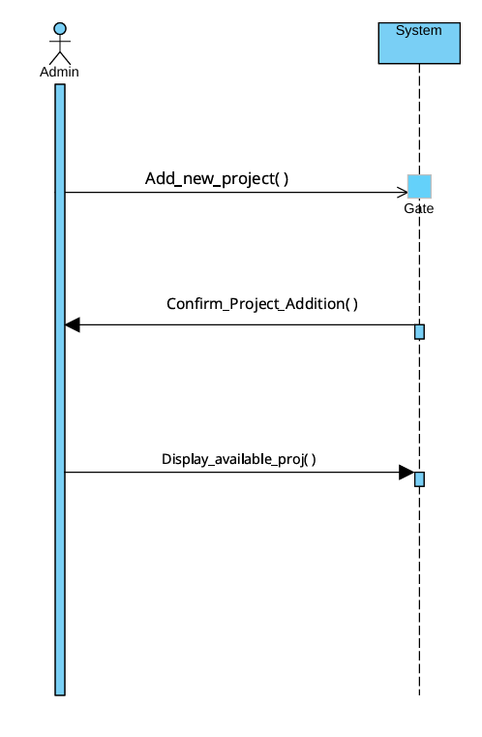

**UC 2: Project Registration**

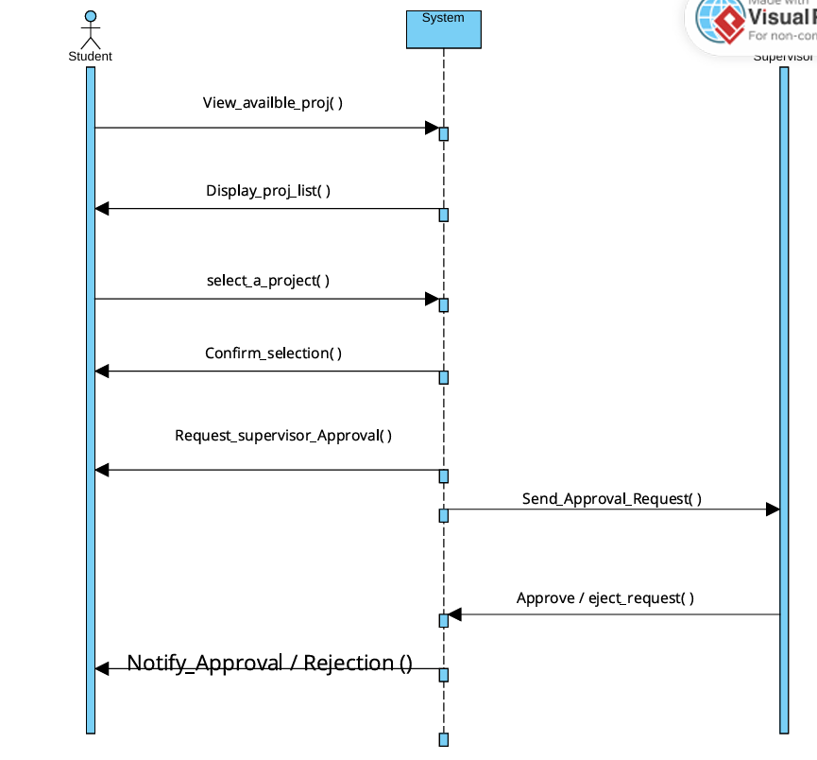

**UC 3: Upload work product:**

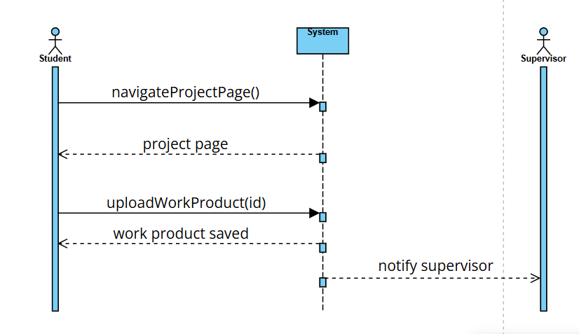

**UC 4: Give Feedback:**

**Domain Model:**

